EX6.9
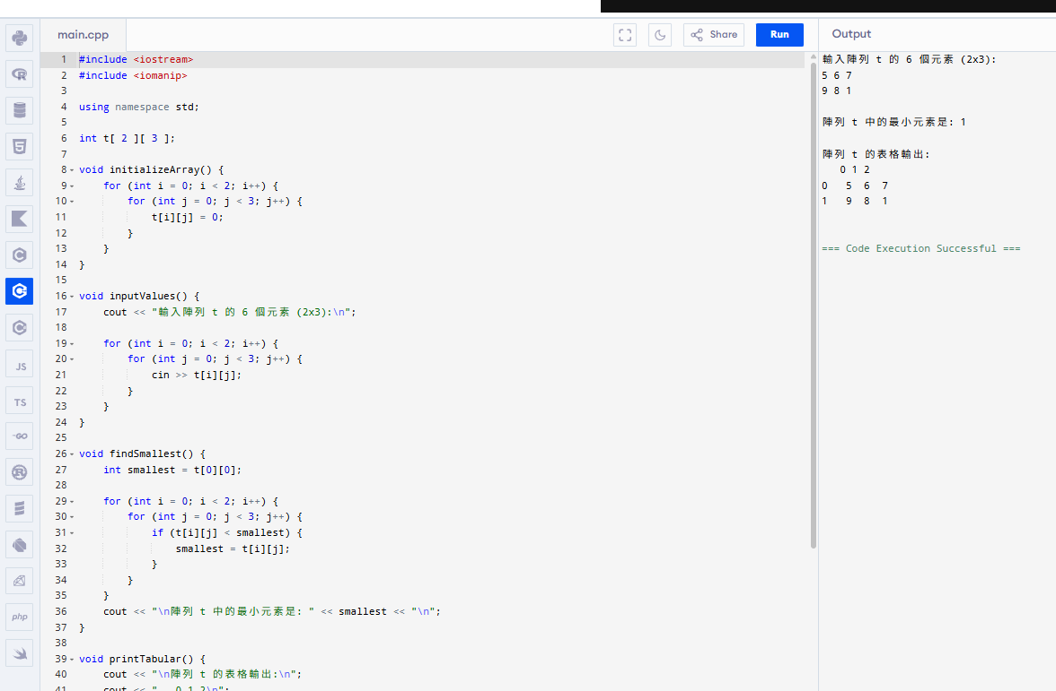
#include <iostream>
#include <iomanip>

using namespace std;

int t[ 2 ][ 3 ];

void initializeArray() {
for (int i = 0; i < 2; i++) {
for (int j = 0; j < 3; j++) {
t[i][j] = 0;
}
}
}

void inputValues() {
cout << "輸入陣列 t 的 6 個元素 (2x3):\n";

for (int i = 0; i < 2; i++) {
for (int j = 0; j < 3; j++) {
cin >> t[i][j];
}
}
}

void findSmallest() {
int smallest = t[0][0];

for (int i = 0; i < 2; i++) {
for (int j = 0; j < 3; j++) {
if (t[i][j] < smallest) {
smallest = t[i][j];
}
}
}
cout << "\n陣列 t 中的最小元素是: " << smallest << "\n";
}

void printTabular() {
cout << "\n陣列 t 的表格輸出:\n";
cout << " 0 1 2\n";

for (int r = 0; r < 2; r++) {
cout << r << ' ';
for (int c = 0; c < 3; c++) {
cout << setw(3) << t[r][c];
}
cout << '\n';
}
}

int main() {
initializeArray();

inputValues();

findSmallest();

printTabular();

return 0;
}
EX6.22
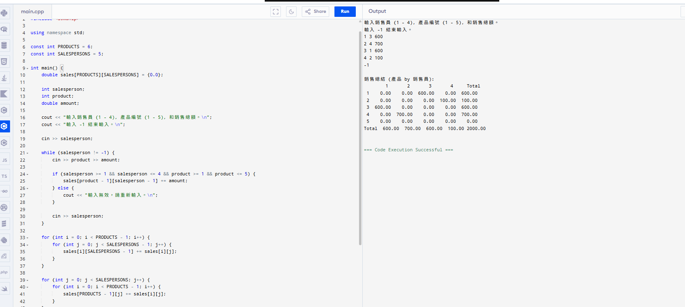

#include <iostream>
#include <iomanip>

using namespace std;

const int PRODUCTS = 6;
const int SALESPERSONS = 5;

int main() {
double sales[PRODUCTS][SALESPERSONS] = {0.0};

int salesperson;
int product;
double amount;

cout << "輸入銷售員 (1 - 4), 產品編號 (1 - 5), 和銷售總額。\n";
cout << "輸入 -1 結束輸入。\n";

cin >> salesperson;

while (salesperson != -1) {
cin >> product >> amount;

if (salesperson >= 1 && salesperson <= 4 && product >= 1 && product <= 5) {
sales[product - 1][salesperson - 1] += amount;
} else {
cout << "輸入無效，請重新輸入。\n";
}

cin >> salesperson;
}

for (int i = 0; i < PRODUCTS - 1; i++) {
for (int j = 0; j < SALESPERSONS - 1; j++) {
sales[i][SALESPERSONS - 1] += sales[i][j];
}
}

for (int j = 0; j < SALESPERSONS; j++) {
for (int i = 0; i < PRODUCTS - 1; i++) {
sales[PRODUCTS - 1][j] += sales[i][j];
}
}

cout << "\n銷售總結 (產品 by 銷售員):\n";
cout << " 1 2 3 4 Total\n";

for (int i = 0; i < PRODUCTS - 1; i++) {
cout << setw(2) << i + 1;
for (int j = 0; j < SALESPERSONS; j++) {
cout << setw(8) << fixed << setprecision(2) << sales[i][j];
}
cout << endl;
}

cout << "Total";
for (int j = 0; j < SALESPERSONS; j++) {
cout << setw(8) << fixed << setprecision(2) << sales[PRODUCTS - 1][j];
}
cout << endl;

return 0;
}

